A Glove of Their Own
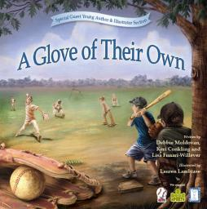
Baseball stars across the country are stepping up to support a new children’s book, A Glove of Their Own. The book aims to teach children the value of sharing what you have with those in need. And The Kevin J. Hannaford, Sr. Foundation, Inc. is proud to be one of the charities that will benefit from sales of the book.
Bob Salomon, the head of the movement promoting this book said "As a little league coach and proud father of two, I am fortunate enough to be passionate about the 'pay it forward' or 'give it back' mindset that has slowly been catching on throughout corporate America. A Glove of Their Own is a children’s picture book that personifies this mentality. It utilizes baseball, and an underprivileged group of boys’ childhood experience. Their love of the game is not defined by the equipment they don’t have but rather the passion and dreams that they do have."
The book was inspired by a birthday party held for one of the writers, Debbie Moldovan’s, children. In place of gifts, guests were asked to donate baseball equipment for children who normally do without. A Glove of Their Own has caught the attention of big-hearted baseball players including Robb Quinlan, Jack Hannahan, Sean Casey and Craig Biggio.
Click here for a story about the book from the NY POST .
The book comes out in October but reserve copies can be ordered now at A Glove of Their Own website . Be sure to click on the Charity code KJH 138 from the drop-down box and The Kevin J. Hannaford, Sr. Foundation, Inc. will receive a portion of the sale.

